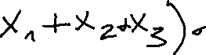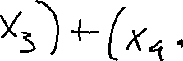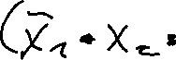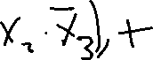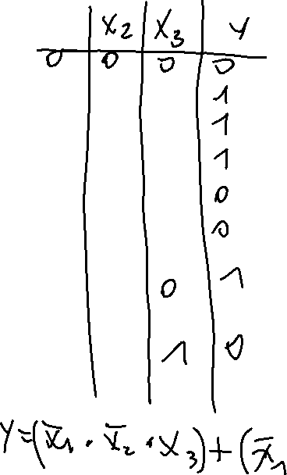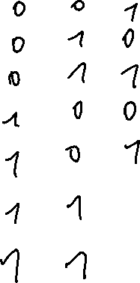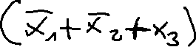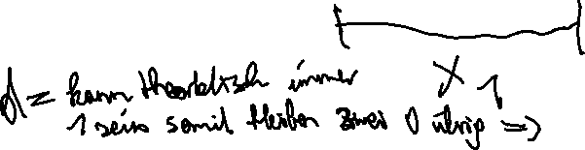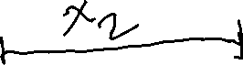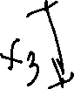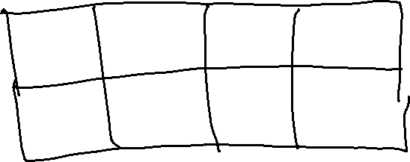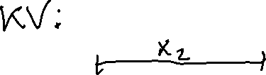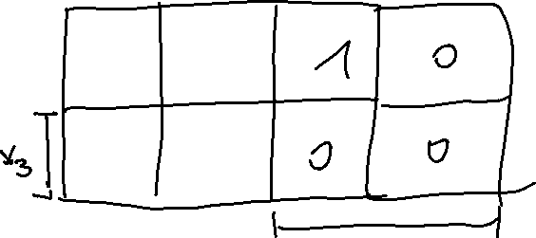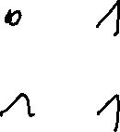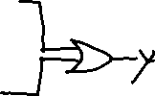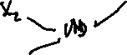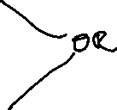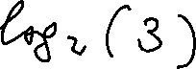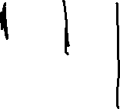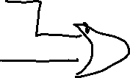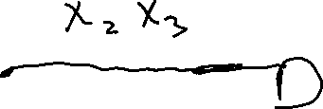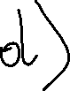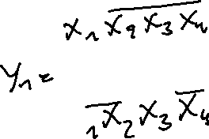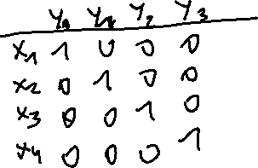

c)

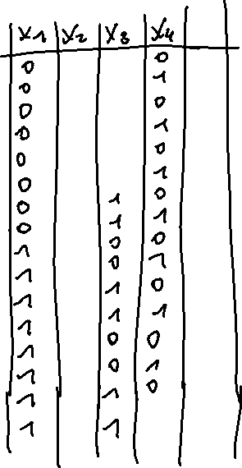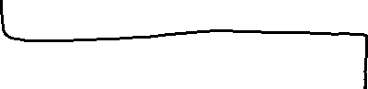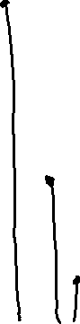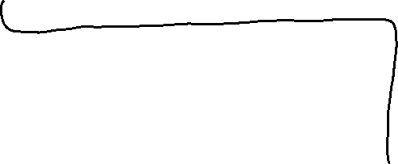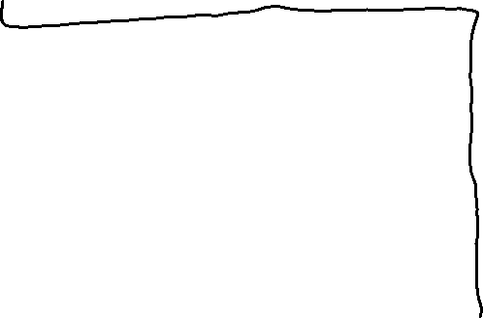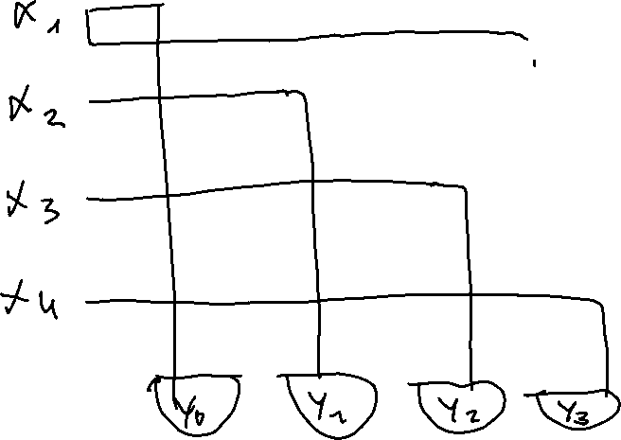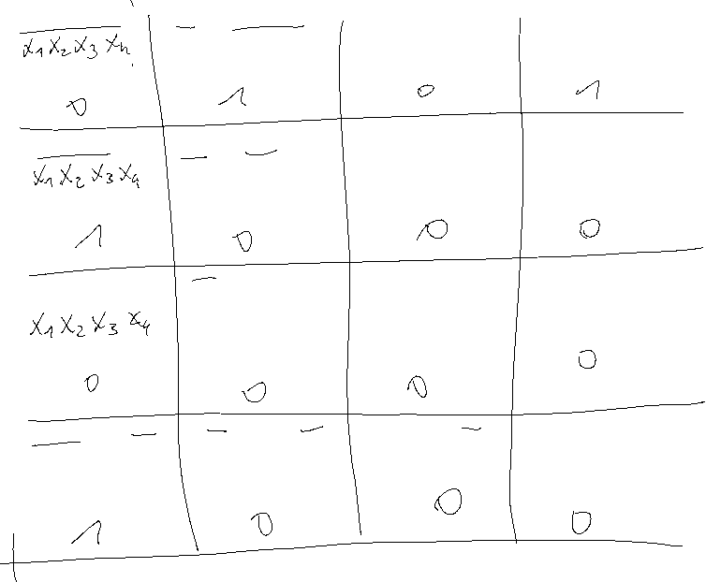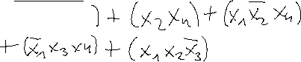

|  |  |  |  |  |  |
| --- | --- | --- | --- | --- | --- |
| X1 | X2 | X3 | X4 | y | Tastenkomb. |
| 1 | 1 | 1 | 1 | S | o,l,u,r |
| 0 | 1 | 1 | 1 | S | l,u,r |
| 1 | 0 | 1 | 1 | S | o,u,r |
| 1 | 1 | 0 | 1 | S | O,l,r |
| 1 | 1 | 1 | 0 | S | O,l,u |
| 0 | 0 | 1 | 1 | S | U,r |
| 0 | 1 | 0 | 1 | S | L,r |
| 0 | 1 | 1 | 0 | S | L,u |
| 1 | 0 | 0 | 1 | S | O,r |
| 1 | 0 | 1 | 0 | S | O,u |
| 1 | 1 | 0 | 0 | S | O,l |
| 1 | 0 | 0 | 0 | Y0 => 0 0 | O |
| 0 | 1 | 0 | 0 | Y1 => 0 1 | L |
| 0 | 0 | 1 | 0 | Y2 => 1 0 | U |
| 0 | 0 | 0 | 1 | Y3 => 1 1 | R |
|  |  |  |  |  |  |